Exercise 1: Implementing the Singleton Pattern
Scenario:
You need to ensure that a logging utility class in your application has only one instance throughout the application lifecycle to ensure consistent logging.
SOLUTION
Logger.java
public class Logger {
private static Logger instance;

private Logger() {
}

public static Logger getInstance() {
if (instance == null) {
instance = new Logger();
}
return instance;
}

public void log(String message) {
System.out.println(message);
}
}
SingletonTest.java
public class SingletonTest {
public static void main(String[] args) {
Logger logger1 = Logger.getInstance();
Logger logger2 = Logger.getInstance();

System.out.println(logger1 == logger2);

logger1.log("First Message");
logger2.log("Second Message"); } }
OUTPUT:
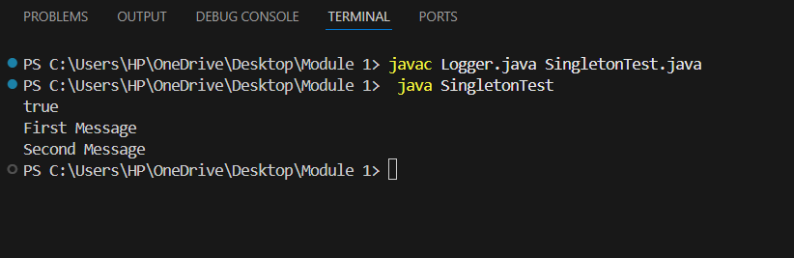
Exercise 2: Implementing the Factory Method Pattern
Scenario:
You are developing a document management system that needs to create different types of documents (e.g., Word, PDF, Excel). Use the Factory Method Pattern to achieve this.
SOLUTION:
Document.java
public interface Document {
void open();
}
WordDocument.java
public class WordDocument implements Document {
public void open() {
System.out.println("Opening Word Document");
}
}
PdfDocument.java
public class PdfDocument implements Document {
public void open() {
System.out.println("Opening PDF Document");
}
}
ExcelDocument.java
public class ExcelDocument implements Document {
public void open() {
System.out.println("Opening Excel Document");
}
}
DocumentFactory.java
public abstract class DocumentFactory {
public abstract Document createDocument();
}
WordFactory.java
public class WordFactory extends DocumentFactory {
public Document createDocument() {
return new WordDocument();
}
}
PdfFactory.java
public class PdfFactory extends DocumentFactory {
public Document createDocument() {
return new PdfDocument();
}
}
ExcelFactory.java
public class ExcelFactory extends DocumentFactory {
public Document createDocument() {
return new ExcelDocument();
}
}
FactoryTest.java
public class FactoryTest {
public static void main(String[] args) {
DocumentFactory factory = new WordFactory();
Document doc = factory.createDocument();
doc.open();
factory = new PdfFactory();
doc = factory.createDocument();
doc.open();
factory = new ExcelFactory();
doc = factory.createDocument();
doc.open();
}
}

OUTPUT:
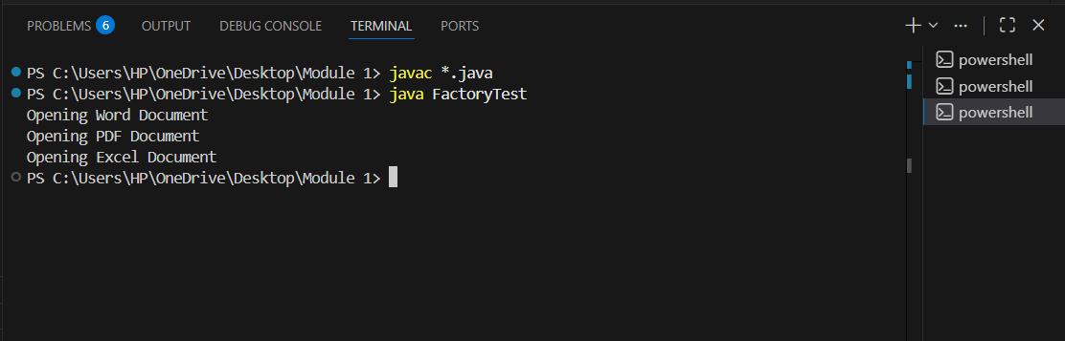

Exercise 3: Implementing the Builder Pattern
Scenario:
You are developing a system to create complex objects such as a Computer with multiple optional parts. Use the Builder Pattern to manage the construction process.
SOLUTION:
Computer.java
public class Computer {
private String cpu;
private int ram;
private int storage;
private Computer(Builder builder) {
this.cpu = builder.cpu;
this.ram = builder.ram;
this.storage = builder.storage;
}
public void display() {
System.out.println(cpu + " " + ram + "GB " + storage + "GB");
}
public static class Builder {
private String cpu;
private int ram;
private int storage;
public Builder setCpu(String cpu) {
this.cpu = cpu;
return this;
}
public Builder setRam(int ram) {
this.ram = ram;
return this;
}
public Builder setStorage(int storage) {
this.storage = storage;
return this;
}
public Computer build() {
return new Computer(this);
}
}
}
BuilderTest.java
public class BuilderTest {
public static void main(String[] args) {
Computer computer = new Computer.Builder()
.setCpu("Intel i7")
.setRam(16)
.setStorage(512)
.build();
computer.display();
}
}
OUTPUT:
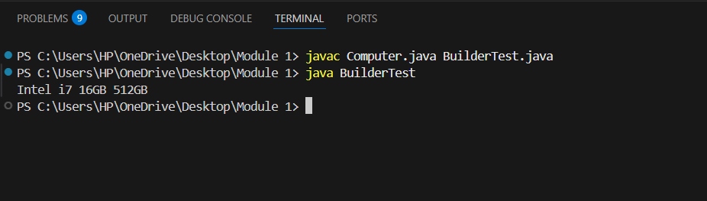

Exercise 4: Implementing the Adapter Pattern
Scenario:
You are developing a payment processing system that needs to integrate with multiple third-party payment gateways with different interfaces. Use the Adapter Pattern to achieve this.

SOLUTION:
PaymentProcessor.java
public interface PaymentProcessor {
void processPayment(double amount);
}
PayPalGateway.java
public class PayPalGateway {
public void makePayment(double amount) {
System.out.println("PayPal Payment: " + amount);
}
}
StripeGateway.java
public class StripeGateway {
public void payAmount(double amount) {
System.out.println("Stripe Payment: " + amount);
}
}
PayPalAdapter.java
public class PayPalAdapter implements PaymentProcessor {
private PayPalGateway gateway;
public PayPalAdapter(PayPalGateway gateway) {
this.gateway = gateway;
}
public void processPayment(double amount) {
gateway.makePayment(amount);
}
}
StripeAdapter.java
public class StripeAdapter implements PaymentProcessor {
private StripeGateway gateway;
public StripeAdapter(StripeGateway gateway) {
this.gateway = gateway;
}
public void processPayment(double amount) {
gateway.payAmount(amount);
}
}
AdapterTest.java
public class AdapterTest {
public static void main(String[] args) {
PaymentProcessor p1 = new PayPalAdapter(new PayPalGateway());
p1.processPayment(1000);
PaymentProcessor p2 = new StripeAdapter(new StripeGateway());
p2.processPayment(2000);
}
}
OUTPUT:
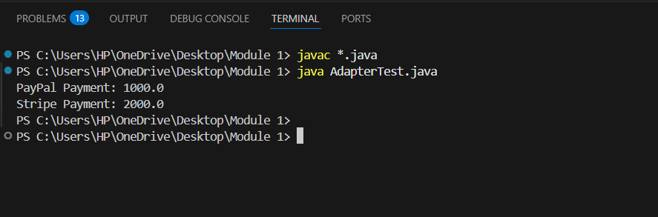

Exercise 5: Implementing the Decorator Pattern
Scenario:
You are developing a notification system where notifications can be sent via multiple channels (e.g., Email, SMS). Use the Decorator Pattern to add functionalities dynamically.
SOLUTION:
Notifier.java
public interface Notifier {
void send(String message);
}
EmailNotifier.java
public class EmailNotifier implements Notifier {
public void send(String message) {
System.out.println("Email: " + message);
}
}
NotifierDecorator.java
public abstract class NotifierDecorator implements Notifier {
protected Notifier notifier;
public NotifierDecorator(Notifier notifier) {
this.notifier = notifier;
}
}
SMSNotifierDecorator.java
public class SMSNotifierDecorator extends NotifierDecorator {
public SMSNotifierDecorator(Notifier notifier) {
super(notifier);
}
public void send(String message) {
notifier.send(message);
System.out.println("SMS: " + message);
}
}
SlackNotifierDecorator.java
public class SlackNotifierDecorator extends NotifierDecorator {
public SlackNotifierDecorator(Notifier notifier) {
super(notifier);
}
public void send(String message) {
notifier.send(message);
System.out.println("Slack: " + message);
}
}
DecoratorTest.java
public class DecoratorTest {
public static void main(String[] args) {
Notifier notifier =
new SlackNotifierDecorator(
new SMSNotifierDecorator(
new EmailNotifier()));
notifier.send("Hello");
}
}
OUTPUT:
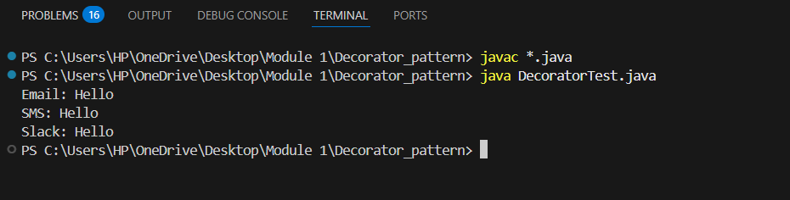
Exercise 6: Implementing the Proxy Pattern
Scenario:
You are developing an image viewer application that loads images from a remote server. Use the Proxy Pattern to add lazy initialization and caching.
SOLUTION:
Image.java
public interface Image {
void display();
}
RealImage.java
public class RealImage implements Image {
private String fileName;
public RealImage(String fileName) {
this.fileName = fileName;
loadFromServer();
}
private void loadFromServer() {
System.out.println("Loading " + fileName);
}
public void display() {
System.out.println("Displaying " + fileName);
}
}
ProxyImage.java
public class ProxyImage implements Image {
private RealImage realImage;
private String fileName;
public ProxyImage(String fileName) {
this.fileName = fileName;
}
public void display() {
if (realImage == null) {
realImage = new RealImage(fileName);
}
realImage.display();
}
}
ProxyTest.java
public class ProxyTest {
public static void main(String[] args) {
Image image = new ProxyImage("sample.jpg");
image.display();
image.display();
}
}
OUTPUT:
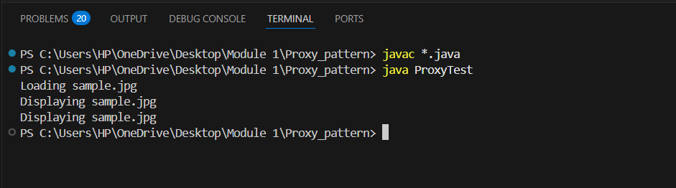

Exercise 7: Implementing the Observer Pattern
Scenario:
You are developing a stock market monitoring application where multiple clients need to be notified whenever stock prices change. Use the Observer Pattern to achieve this.
SOLUTION:
Observer.java
public interface Observer {
void update(String stockName, double price);
}
Stock.java
public interface Stock {
void registerObserver(Observer observer);
void deregisterObserver(Observer observer);
void notifyObservers();
}
StockMarket.java
import java.util.ArrayList;
import java.util.List;
public class StockMarket implements Stock {
private List<Observer> observers = new ArrayList<>();
private String stockName;
private double price;
public void setStock(String stockName, double price) {
this.stockName = stockName;
this.price = price;
notifyObservers();
}
public void registerObserver(Observer observer) {
observers.add(observer);
}
public void deregisterObserver(Observer observer) {
observers.remove(observer);
}
public void notifyObservers() {
for (Observer observer : observers) {
observer.update(stockName, price);
}
}
}
MobileApp.java
public class MobileApp implements Observer {
public void update(String stockName, double price) {
System.out.println("Mobile App: " + stockName + " " + price);
}
}
WebApp.java
public class WebApp implements Observer {
public void update(String stockName, double price) {
System.out.println("Web App: " + stockName + " " + price);
}
}
ObserverTest.java
public class ObserverTest {
public static void main(String[] args) {
StockMarket market = new StockMarket();
Observer mobile = new MobileApp();
Observer web = new WebApp();
market.registerObserver(mobile);
market.registerObserver(web);
market.setStock("TCS", 3800);
}
}
OUTPUT:
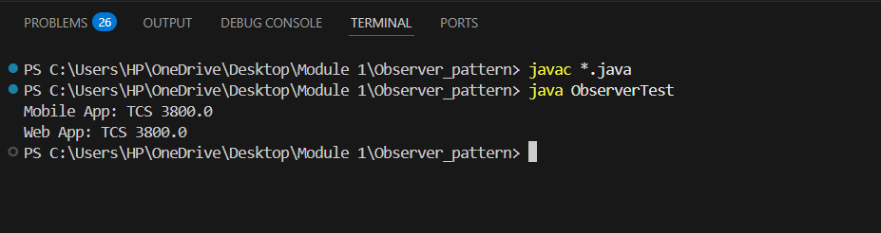

Exercise 8: Implementing the Strategy Pattern
Scenario:
You are developing a payment system where different payment methods (e.g., Credit Card, PayPal) can be selected at runtime. Use the Strategy Pattern to achieve this.
SOLUTION:
PaymentStrategy.java
public interface PaymentStrategy {
void pay(int amount);
}
CreditCardPayment.java
public class CreditCardPayment implements PaymentStrategy {
public void pay(int amount) {
System.out.println("Paid " + amount + " using Credit Card");
}
}
PayPalPayment.java
public class PayPalPayment implements PaymentStrategy {
public void pay(int amount) {
System.out.println("Paid " + amount + " using PayPal");
}
}
PaymentContext.java
public class PaymentContext {
private PaymentStrategy strategy;
public PaymentContext(PaymentStrategy strategy) {
this.strategy = strategy;
}
public void executePayment(int amount) {
strategy.pay(amount);
}
}
StrategyTest.java
public class StrategyTest {
public static void main(String[] args) {
PaymentContext context =
new PaymentContext(new CreditCardPayment());
context.executePayment(5000);
context =
new PaymentContext(new PayPalPayment());
context.executePayment(3000);
}
}
OUTPUT:
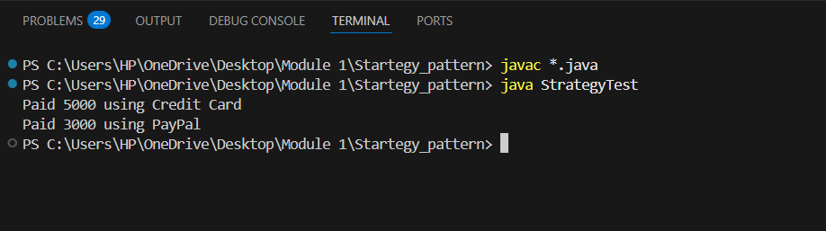

Exercise 9: Implementing the Command Pattern
Scenario: You are developing a home automation system where commands can be issued to turn devices on or off. Use the Command Pattern to achieve this.
SOLUTION:
Command.java
public interface Command {
void execute();
}
Light.java
public class Light {
public void on() {
System.out.println("Light ON");
}
public void off() {
System.out.println("Light OFF");
}
}
LightOnCommand.java
public class LightOnCommand implements Command {
private Light light;
public LightOnCommand(Light light) {
this.light = light;
}
public void execute() {
light.on();
}
}
LightOffCommand.java
public class LightOffCommand implements Command {
private Light light;
public LightOffCommand(Light light) {
this.light = light;
}
public void execute() {
light.off();
}
}
RemoteControl.java
public class RemoteControl {
private Command command;
public void setCommand(Command command) {
this.command = command;
}
public void pressButton() {
command.execute();
}
}
CommandTest.java
public class CommandTest {
public static void main(String[] args) {
Light light = new Light();
Command on = new LightOnCommand(light);
Command off = new LightOffCommand(light);
RemoteControl remote = new RemoteControl();
remote.setCommand(on);
remote.pressButton();
remote.setCommand(off);
remote.pressButton();
}
}
OUTPUT:
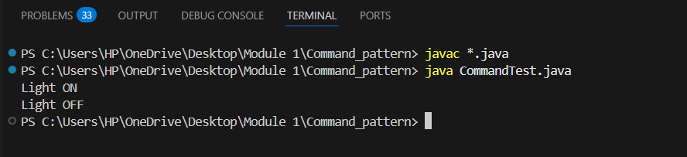

Exercise 10: Implementing the MVC Pattern
Scenario:
You are developing a simple web application for managing student records using the MVC pattern.
SOLUTION:
Student.java
public class Student {
private String name;
private String id;
private String grade;
public String getName() {
return name;
}
public void setName(String name) {
this.name = name;
}
public String getId() {
return id;
}
public void setId(String id) {
this.id = id;
}
public String getGrade() {
return grade;
}
public void setGrade(String grade) {
this.grade = grade;
}
}
StudentView.java
public class StudentView {
public void displayStudentDetails(String name,
String id,
String grade) {
System.out.println("Name: " + name);
System.out.println("ID: " + id);
System.out.println("Grade: " + grade);
}
}
StudentController.java
public class StudentController {
private Student model;
private StudentView view;
public StudentController(Student model,
StudentView view) {
this.model = model;
this.view = view;
}
public void setStudentName(String name) {
model.setName(name);
}
public void setStudentGrade(String grade) {
model.setGrade(grade);
}
public void updateView() {
view.displayStudentDetails(
model.getName(),
model.getId(),
model.getGrade());
}
}
MVCTest.java
public class MVCTest {
public static void main(String[] args) {
Student student = new Student();
student.setName("Naveen");
student.setId("101");
student.setGrade("A");
StudentView view = new StudentView();
StudentController controller =
new StudentController(student, view);
controller.updateView();
controller.setStudentName("Kumar");
controller.setStudentGrade("A+");
controller.updateView();
}
}
OUTPUT:
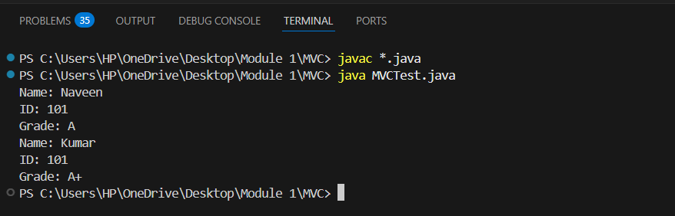
Exercise 11: Implementing Dependency Injection
Scenario:
You are developing a customer management application where the service class depends on a repository class. Use Dependency Injection to manage these dependencies.
SOLUTION:
CustomerRepository.java
public interface CustomerRepository {
String findCustomerById(int id);
}
CustomerRepositoryImpl.java
public class CustomerRepositoryImpl
implements CustomerRepository {
public String findCustomerById(int id) {
return "Customer ID: " + id;
}
}
CustomerService.java
public class CustomerService {
private CustomerRepository repository;
public CustomerService(CustomerRepository repository) {
this.repository = repository;
}
public String getCustomer(int id) {
return repository.findCustomerById(id);
}
}
DependencyInjectionTest.java
public class DependencyInjectionTest {
public static void main(String[] args) {
CustomerRepository repository =
new CustomerRepositoryImpl();
CustomerService service =
new CustomerService(repository);
System.out.println(service.getCustomer(101));
}
}
OUTPUT:
